**Experiment No. 5: Load Cell**

Name: Mansi Uniyal

Roll no.: 19EE10039

Date: 22 Feb 2021







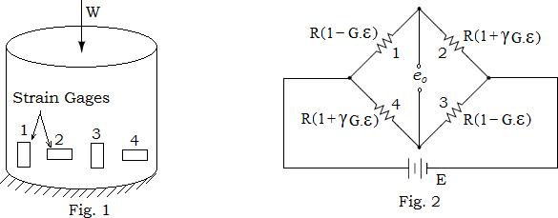

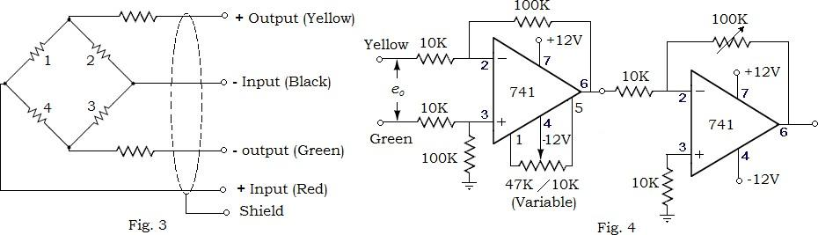

# Simulation Assignment:

# Draw neatly the above circuit shown in Fig. 2 in LTSpice. All the components should be chosen as ideal. Attach the screen-shot of the schematic after entering your Name and Roll No as a text on it. Please see the reference example below.

# 

# Simulate the circuit assuming initial weight W (in Kg) = 10 and poison’s ratio y = 0.2. Attach the screenshots and compute the voltage (Vo+ - Vo-).

**Answer**→ (Vo+ - Vo-) = 17.162323mV

Theoretical value = 17.14mV

Error(%) = 0.117%

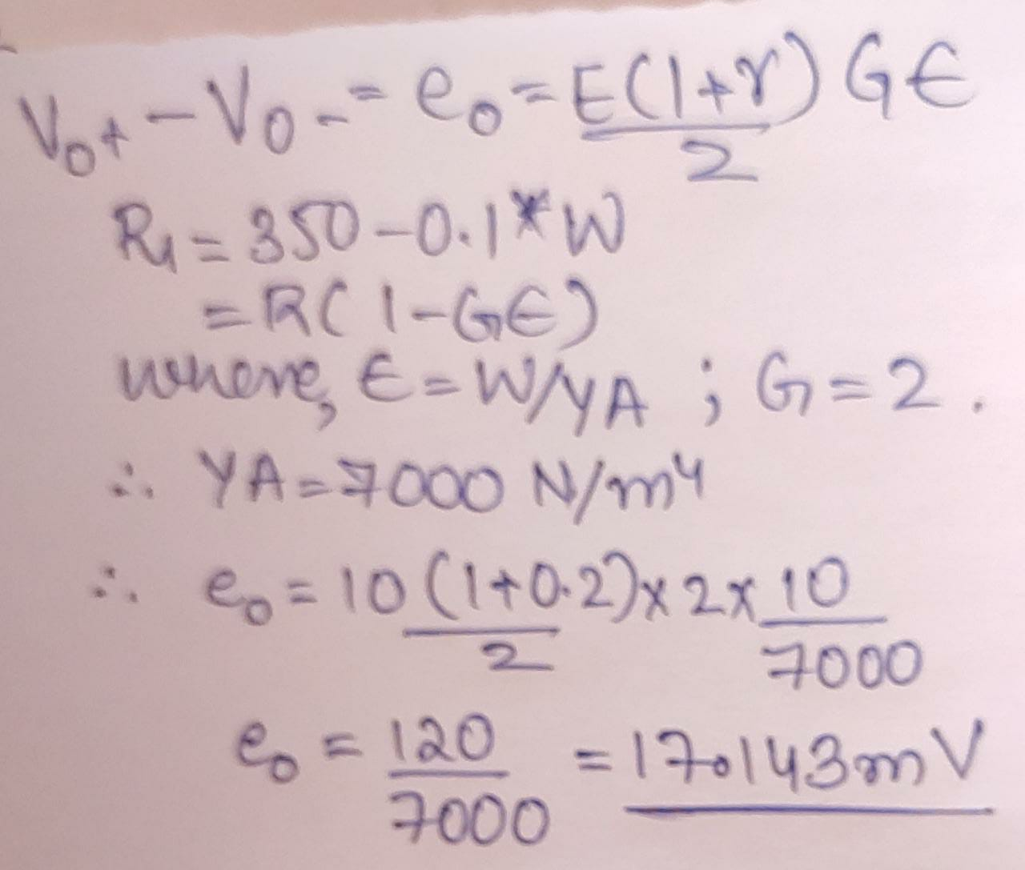

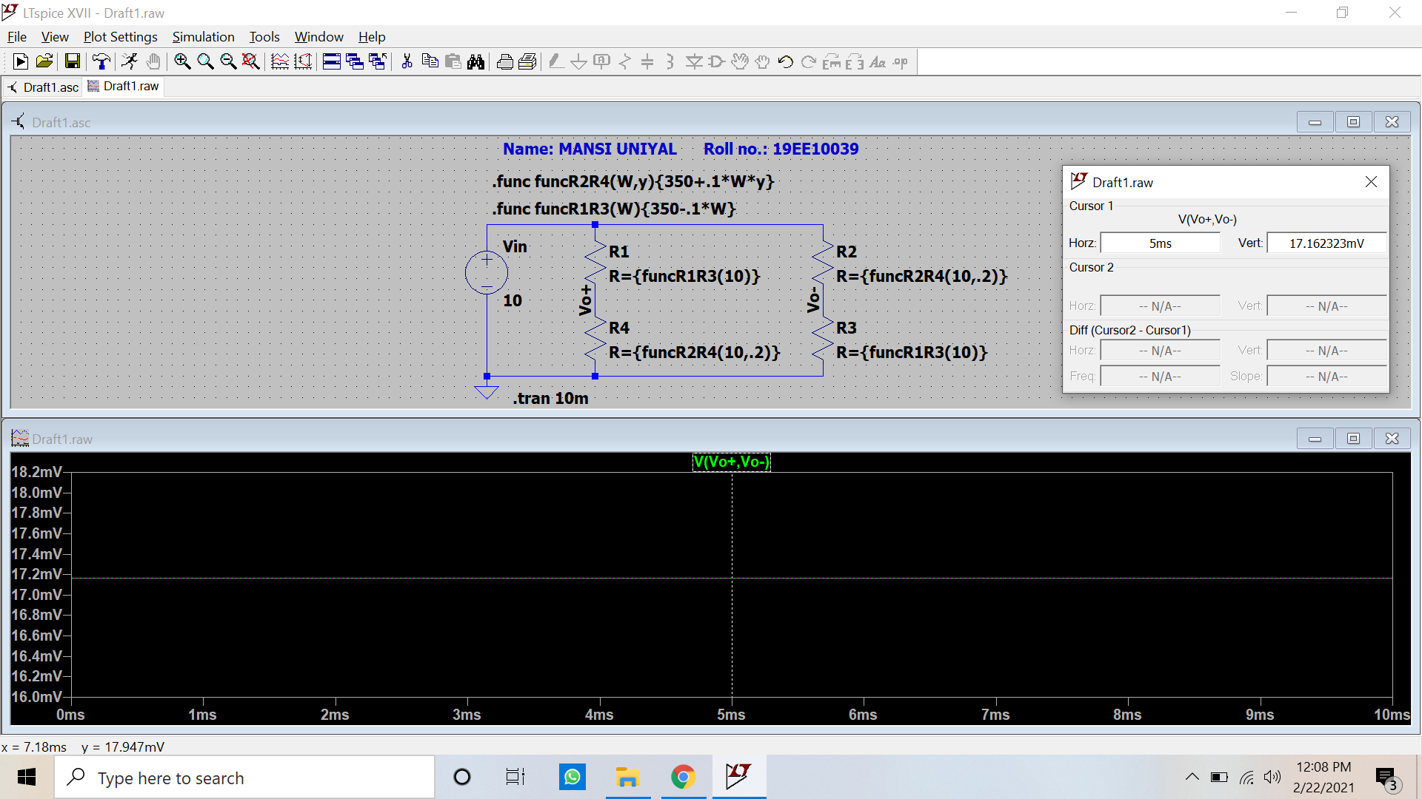

# Add the signal conditioning circuit to the load cell in LTSpice as shown in Fig. 4. All the components should be chosen as ideal. Attach the screen-shot of the schematic after entering your Name and Roll No as a text on it. Please see the reference example below.

# 

# Take the value of the feedback resistor Rf = 100 kΩ. Attach the waveform of Vout and compute its value.

**Answer** →

Experimental value: Vout = 1.6867256V

Theoretical value: Vout = 1.71V

Error(%) = 1.17%

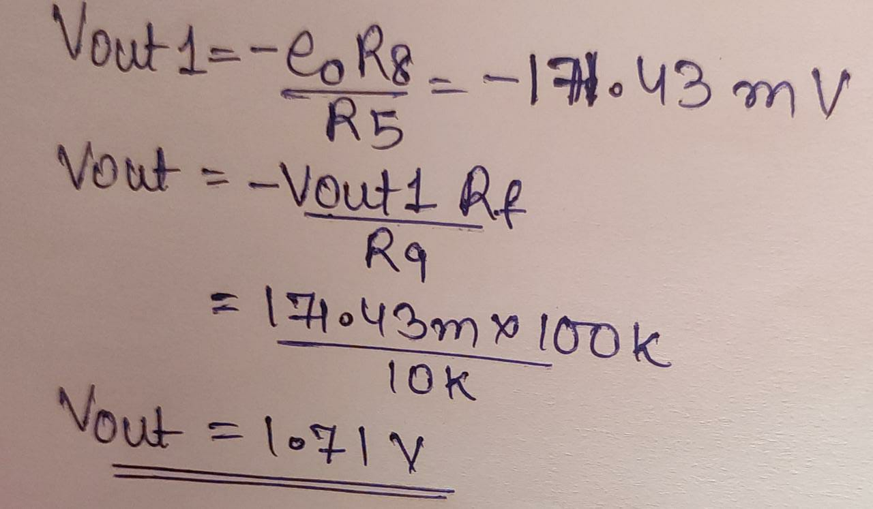

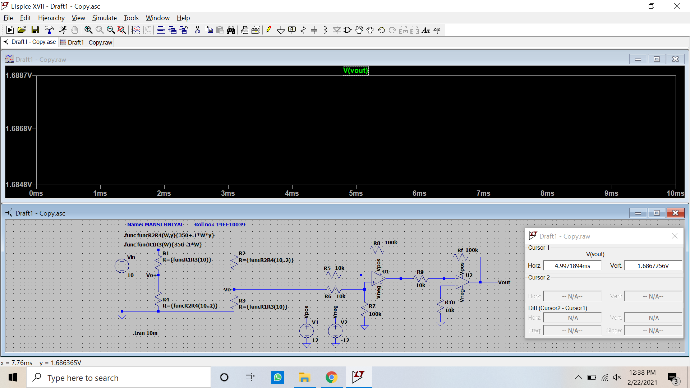

# Now set the value of Rf such that Vout becomes 10 V for W = 10 Kg. With this updated Rf value, only vary the weight value W in the range of 0.5 Kg to 10 Kg with a step of 0.25 Kg, and attach the screenshots of the Vout. Plot the Vout versus W values in a curve.

Experimental value: Vout = 9.8386998V

Theoretical value: Vout = 10V

Error(%) = 1.61%

Slope = Vout/W = Sensitivity = 0.984094 V/kg

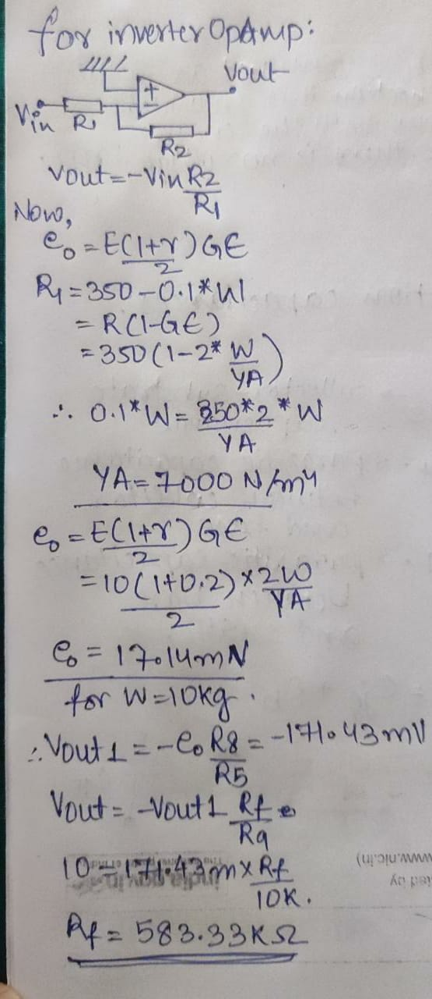

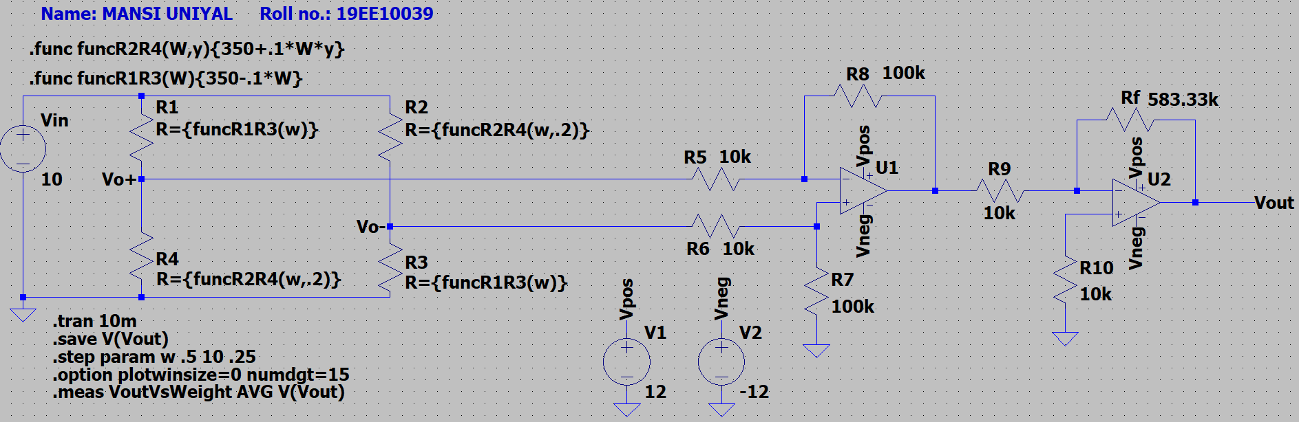

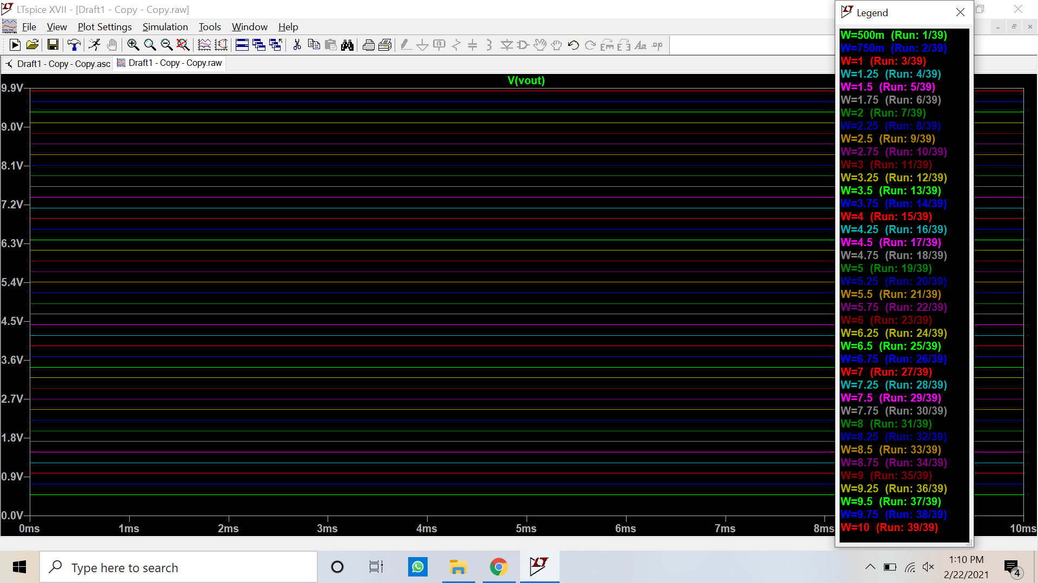

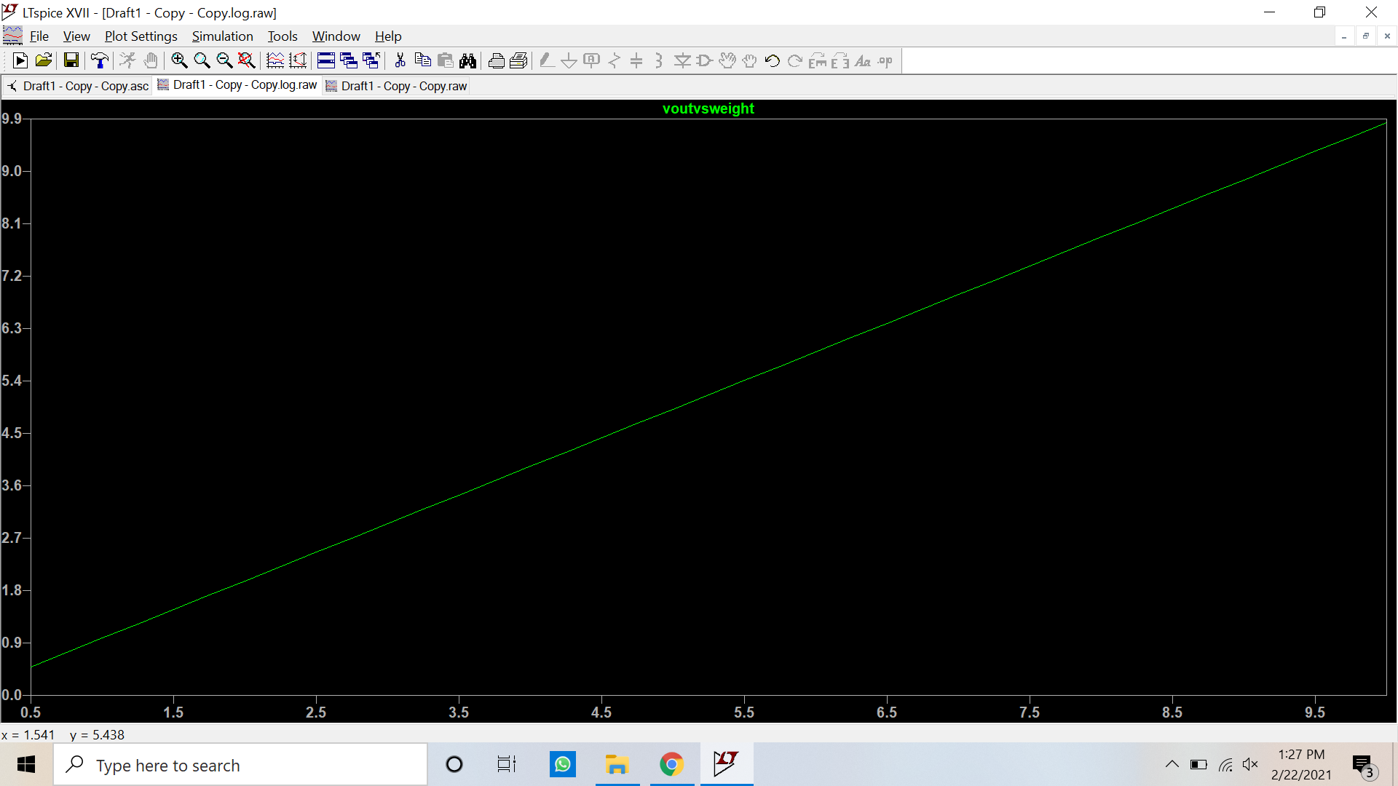

# Change the poison’s ratio to 0.35 and repeat steps 4 and 5.

4) **Answer**→

Experimental value: Vout = 1.8971524V

Theoretical value: Vout = 1.93V

Error(%) = 1.71%

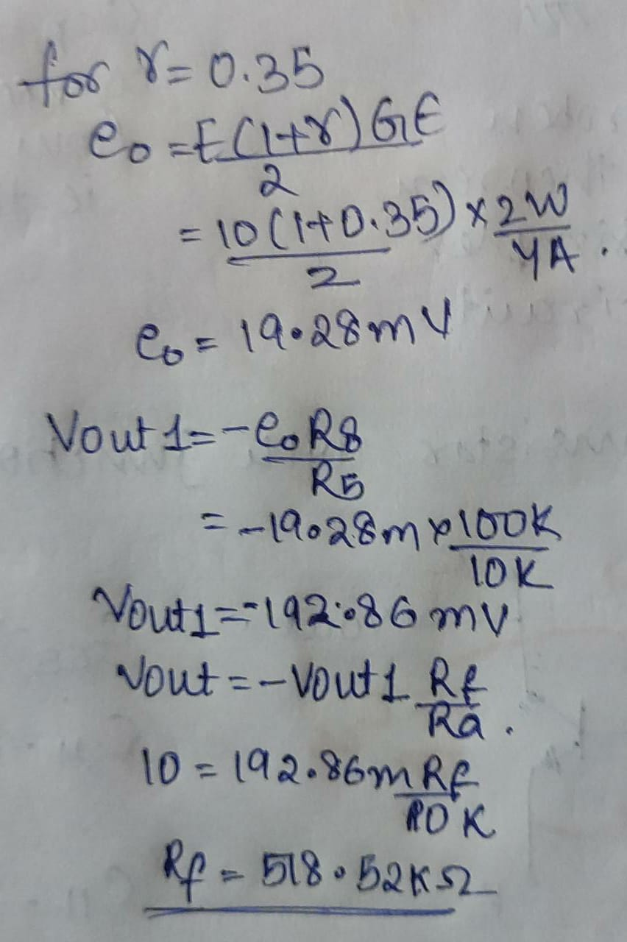

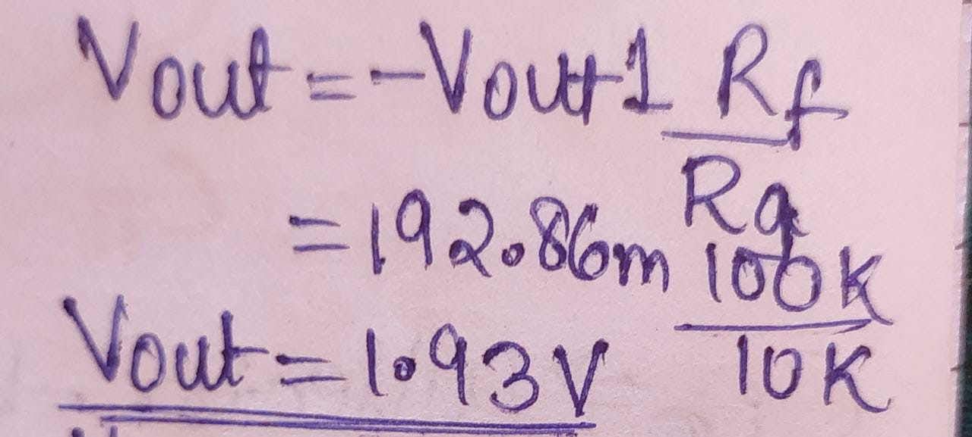

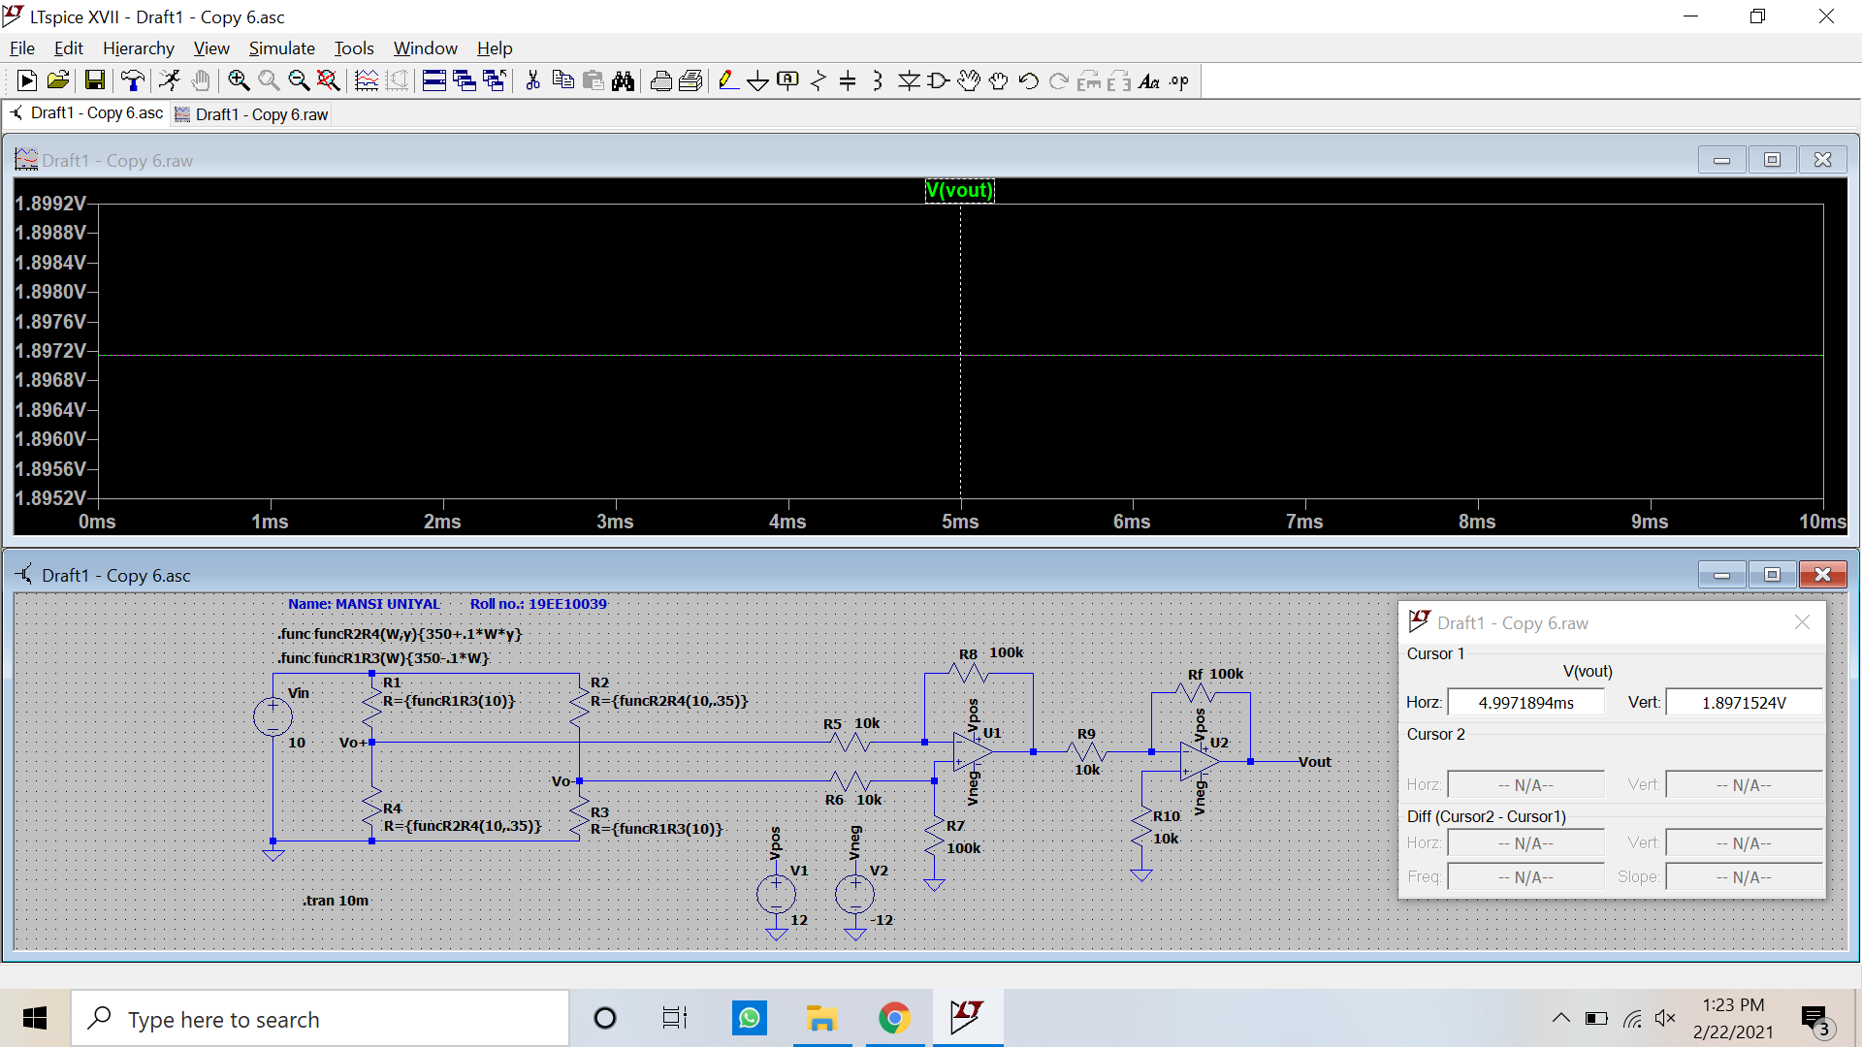

5)

Experimental value: Vout = 9.8367017V

Theoretical value: Vout = 10V

Error(%) = 1.63%

Slope = Vout/W = Sensitivity = 0.983785 V/kg



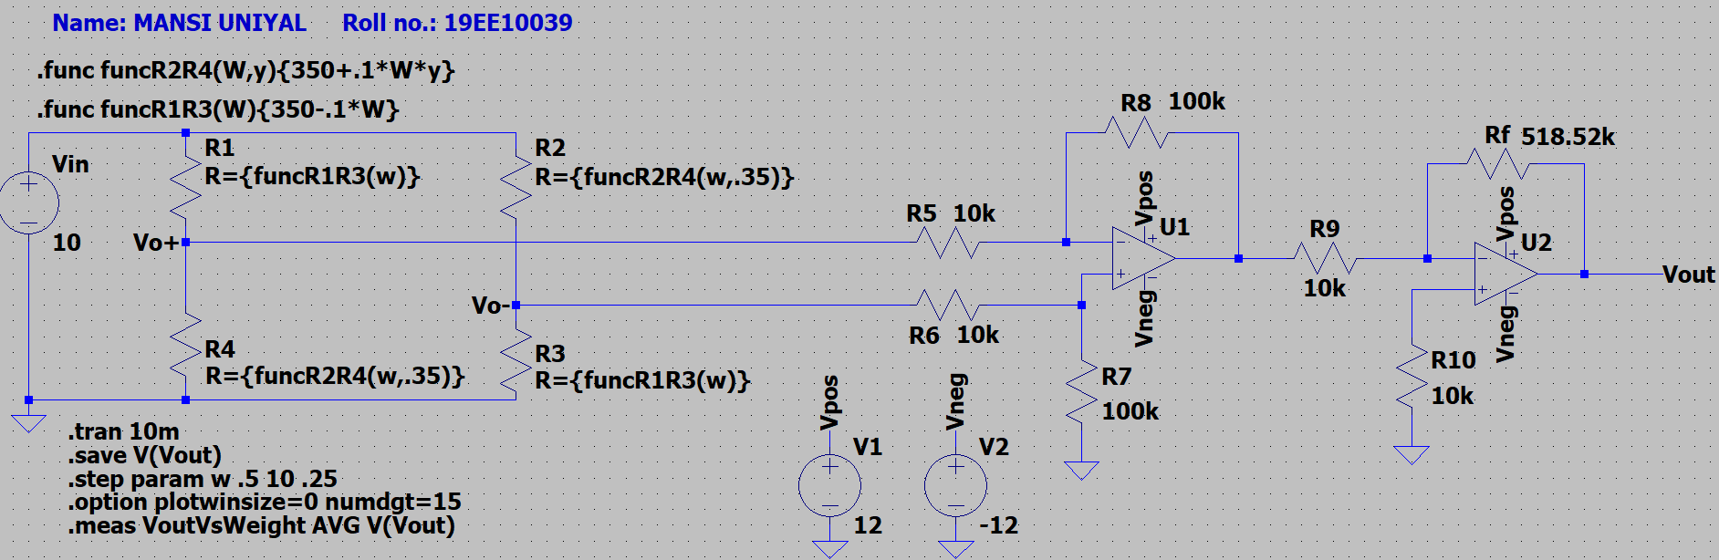

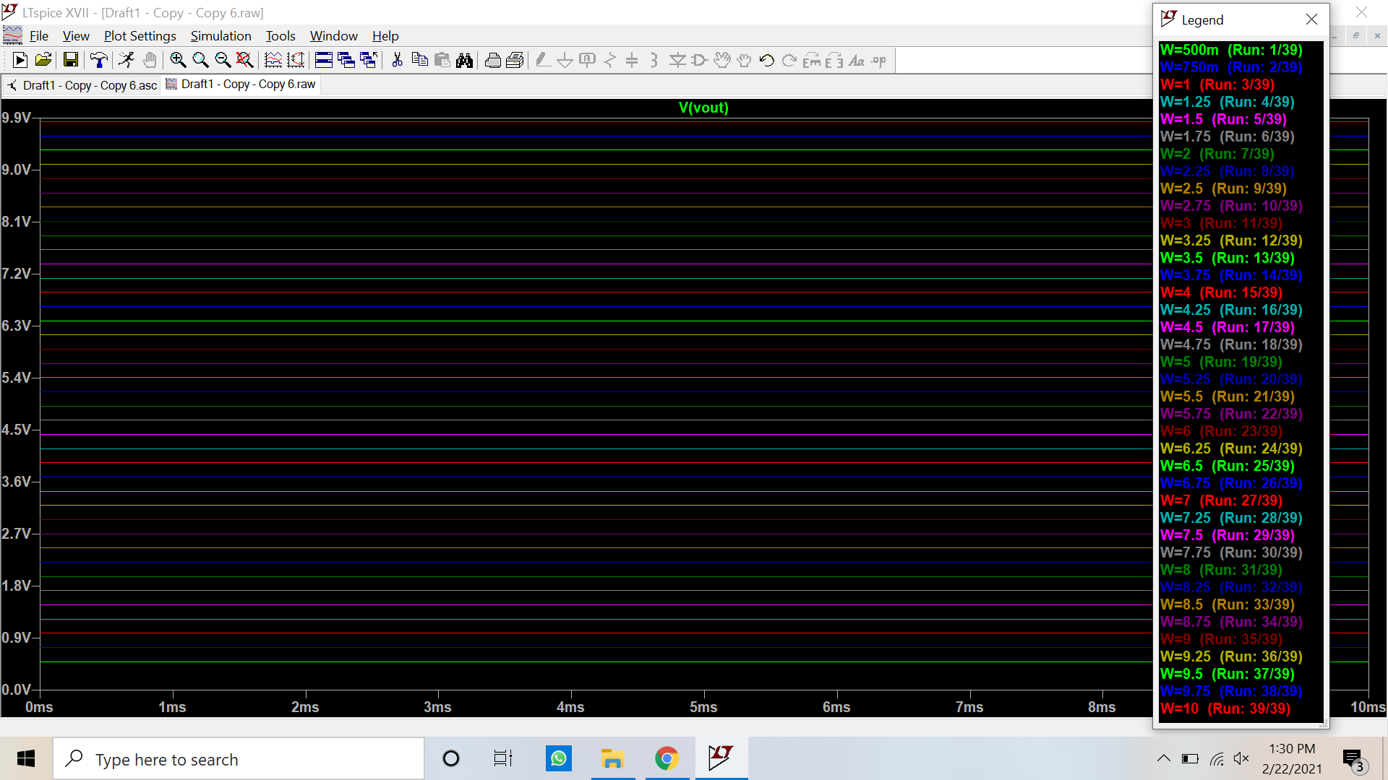

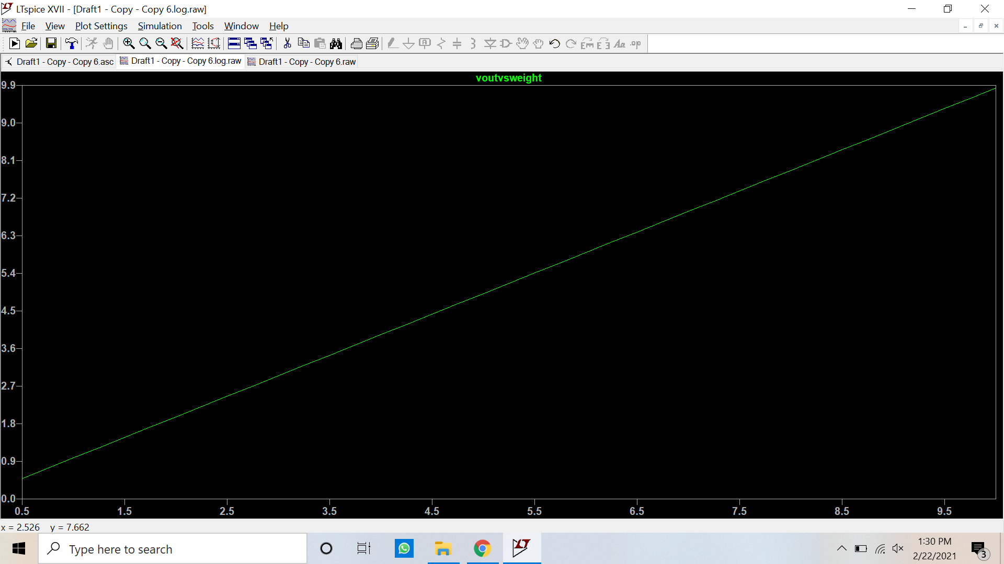

# Discussions:

1. Derive equation (3).

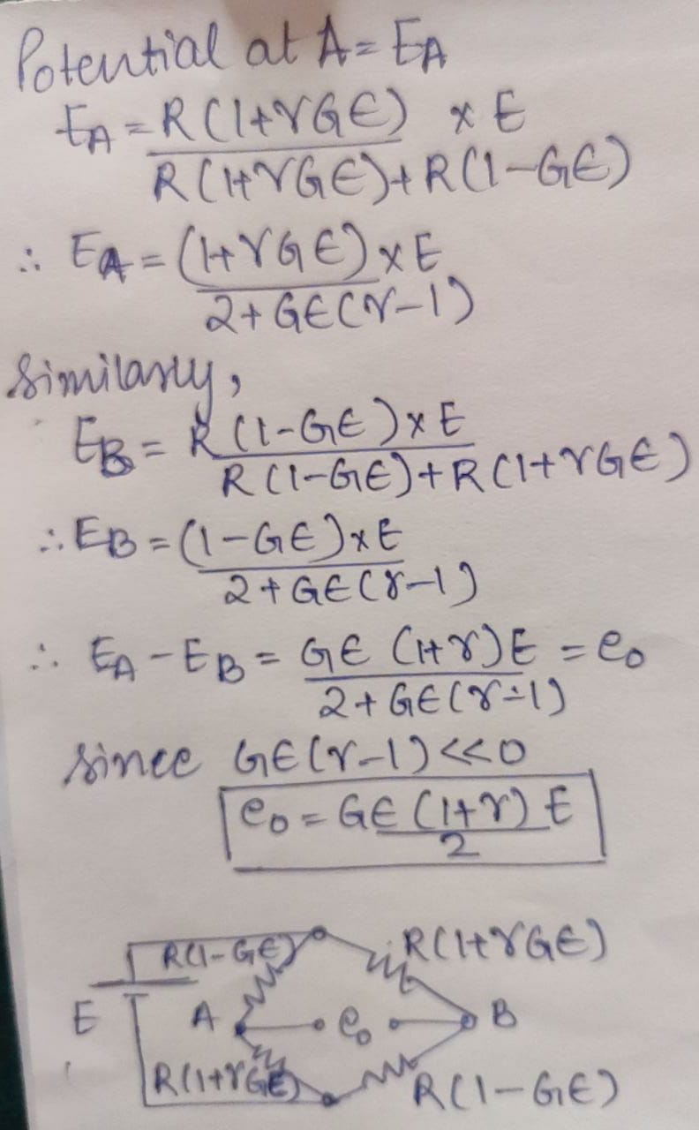

1. The resistance of the strain gauge changes with temperature. But the bridge configuration used here will provide a perfect temperature compensation arrangement. Justify this.

**Answer**→

When weight is applied, there is a strain on the top and compression on the bottom. In the Wheatstone bridge circuit, the result is to double either the strain or compression. If temperature-dependent strain occurs, the strain appears to both strain gauges with either strain or compression but the same.

Due to a change in temperature, there is an effect on all the resistances (R) and the change in resistance (△R) equally. This doesn’t affect the voltage output as their effect gets nullified (as even shown in derivation). The value of G also remains constant as the △R / R factor with the change in temperature increase uniformly, thus not harming the ratio. Thus the effects cancel each other out in the Wheatstone bridge circuit.

1. State some other applications of strain gauges.

**Answer**→

Measurement and monitoring of strain in concrete, rock and steel constructions

Study of stress distribution in the supporting ribs of underground cavities and tunnels

Determination and monitoring of stress distribution in concrete & masonry damsTesting of wye sections

Monitoring of stresses in pressure shafts

**Discussion:**

* Sensor:

The sensor changes the Input energy of any form but the output is in electrical form.

* Transducer:

The transducer changes the Input energy to an output of the same or different form.

* Excitation voltage:

It is any non zero voltage required for the functioning of the Load cell, to extract the change in resistance, to calculate the unbalanced voltage of the wheat stone bridge by the applied excitation voltage.

* Gauge factor (G):

It is constant for a particular strain gauge material, with the typical value of 2 for a metallic strain gauge. It is the ratio of fractional change in electrical resistance to the fractional change in length (strain).

* Due to the discrete nature of the system of stimulation, we obtain a difference in slope with different points for calculating the sensitivity. With the reduced time stamp we observe a minimal change in slope values even with different points.
* With different system resources (there might be a different approximation of the discrete, analogue comparisons), the value of slope (sensitivity) varies. Had there been the use of a similar system then the sensitivity would be much similar.
* In the case of changing the poison’s ration change from .2 to .35 with the change of Rf changes from 583.33kohm to 518.52kohm, to maintain the value of Vout voltage, then there is similar sensitivity obtained that is 0.984094V/kg to 0.983785V/kg.

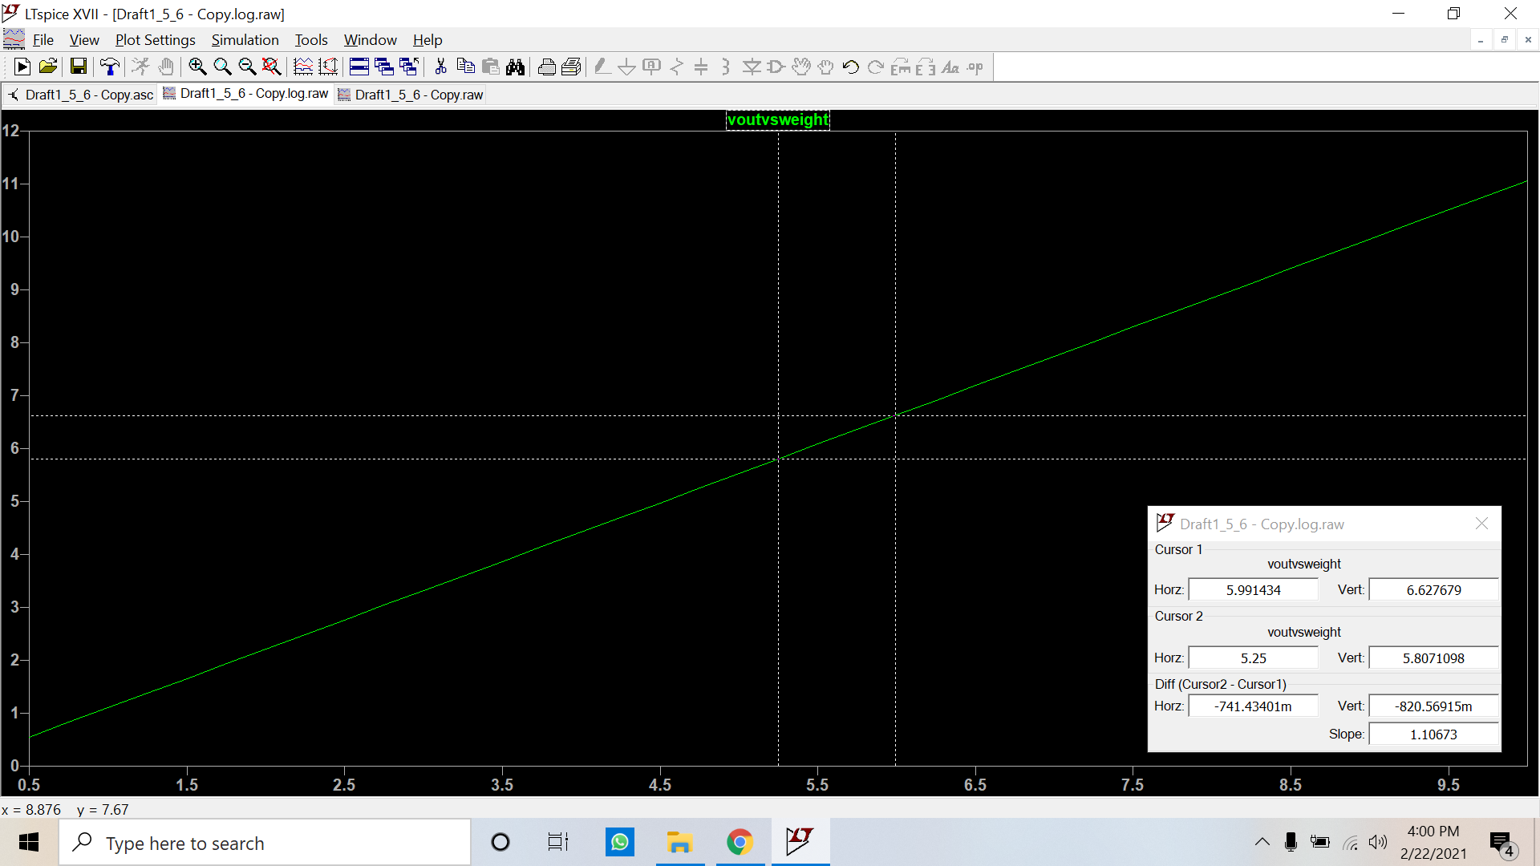

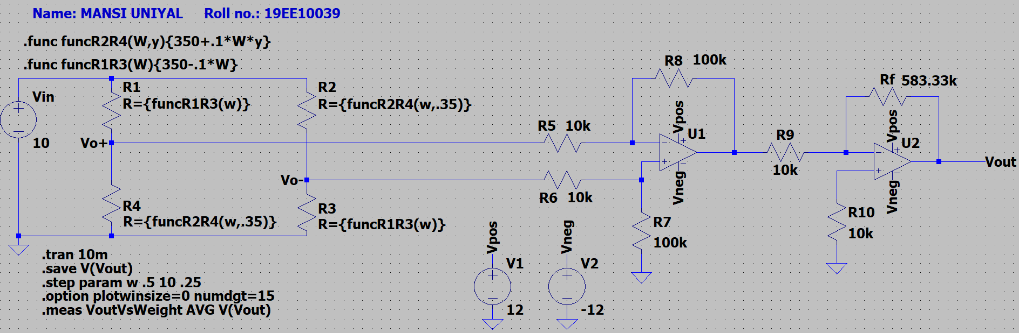

* With the increase in Poisson’s ratio from .2 to .35, there is an increased resistivity. It has a direct dependence on an increase in strain causing an increase in voltage and sensitivity from 0.984094V/kg to 1.10673V/kg, provided that the value of Rf remains constant.